Parth Babbar

Cybersecurity Measures

Introduction:
Cybersecurity in banking is critical for protecting sensitive financial data and guaranteeing transaction integrity. As financial services become more digital, the danger of cyber-attacks increases, emphasizing the necessity for strong cybersecurity measures. This presentation examines the current state of cybersecurity in US banking, including data, issues, advantages, and solutions critical to preserving client confidence and security.
Importance of cybersecurity in banking:
- Data Protection: Ensuring the confidentiality, integrity, and availability of consumer information.
- Fraud Prevention: Detecting and preventing fraudulent activity.
- Regulatory Compliance: Adhering to regulatory regulations for data security and privacy.
Key Features:
- Encryption: Banks employ encryption to secure data both during transit and at rest. The Advanced Encryption Standard (AES) is routinely used to protect sensitive information.
- Multi-Factor Authentication (MFA): MFA increases security by asking users to present several forms of identity before accessing accounts.
- Intrusion Detection Systems (IDS) and Intrusion Prevention Systems (IPS): IDS and IPS scan network traffic for suspicious activities and take appropriate action to avoid possible breaches.
- Firewalls: Firewalls are used to prevent unwanted access to the bank's network while still permitting legal traffic.
- Anti-Malware Solutions: Anti-malware software defends computers against viruses, spyware, and other dangerous software.
- Security Information and Event Management (SIEM): SIEM systems provide real-time analysis of security warnings generated by hardware and software.
- Regular Security Audits and Penetration Testing: These activities aid in identifying and addressing vulnerabilities in the bank's systems.
Benefits:
- Customer Trust: Implementing effective cybersecurity safeguards builds customer trust by ensuring that their sensitive information is secured.
- Regulatory Compliance: Adherence to cybersecurity standards reduces legal fines and improves the bank's reputation.
- Operational Continuity: Preventing cyber threats enables uninterrupted operations and service availability for consumers.
- Financial Protection: Strong cybersecurity minimizes financial damages caused by data breaches, ransomware attacks, and other cyber catastrophes.
- Reputation Management: Protecting against cyber risks contributes to the bank's reputation, which is critical for client retention and growth.
Challenges:
- Evolving Threat Landscape: Cybercriminals are increasingly employing sophisticated tactics such as APTs and zero-day vulnerabilities, which provide a challenge to established protection strategies. Ransomware attacks, which encrypt data for extortion, pose serious concerns. In order to successfully manage these risks and preserve sensitive information, banks must implement robust cybersecurity procedures.
- Regulatory Compliance: Financial institutions must negotiate complicated regulatory frameworks, which include the GLBA and NYDFS Cybersecurity Regulation. Compliance with severe data privacy standards, such as GDPR and CCPA, adds to the difficulty. Managing these rules is critical to guaranteeing legal compliance and safeguarding client data in banking.
- Insider Threats: Malicious insiders can use sensitive information for personal benefit, and inadvertent errors such as misconfigurations can also result in security breaches. Effective security measures and continuing training are required to defend against these dangers in banking.
- Legacy Systems: Many banks use outdated technology that is vulnerable to new cyber-attacks, posing major security risks. Integrating new security solutions with existing old systems can be difficult and expensive, aggravating the difficulty of ensuring strong cybersecurity in banking.
- Third-Party Risks: Vendor weaknesses put banks that rely on third-party services at risk. To get access to bank networks, cyber thieves take advantage of weak supply chain connections. Effective risk management and better security measures are critical for mitigating these hazards in banking.
Solution:
- Improved Threat Detection and Response: In banking, use AI and machine learning to detect and respond to advanced threats. Behavioural analytics track user behaviour in order to detect possible security breaches quickly.
- Improving Regulatory Compliance: Use automated technologies in banking to streamline compliance and ensure regulatory adherence. Conduct frequent audits and assessments to identify and effectively address compliance deficiencies.
- Mitigating Insider Threats: Use strong access controls to restrict employee access to sensitive information depending on their positions. Continuously monitor and track staff activity in order to discover and respond to any questionable conduct in banking settings.
- Upgrading Legacy Systems: Modernize financial systems to ensure security and interoperability with new technologies. Use gradual upgrades to reduce interruptions and expenses.
- Securing Third-Party Relationships: Ensure that vendor risk management and contract security requirements uphold cybersecurity standards.
Statistics:
- According to the Federal Reserve's 2023 report, the number of cyber assaults against financial institutions climbed by 28% over the previous year.
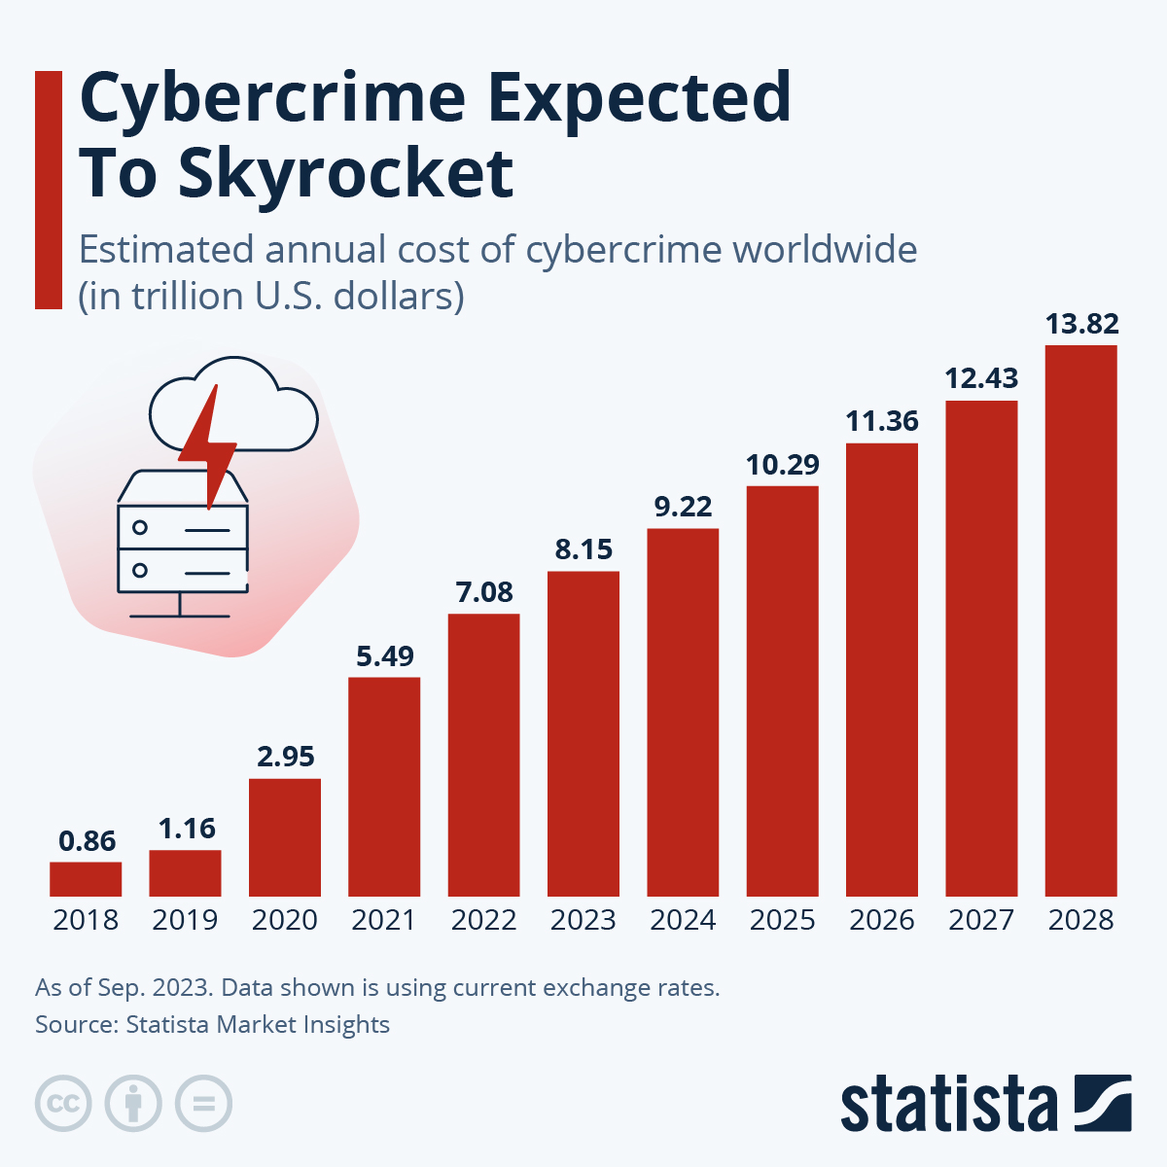
- According to the Identity Theft Resource Center, financial services will account for 18% of all data breaches in 2023, potentially exposing over 100 million records.
- The US banking sector spent around $30 billion on cybersecurity in 2023, a 12% increase over 2022.
- IBM's Cost of a Data Breach Report estimates that the average cost of a data breach in the financial industry will be $5.85 million in 2023.
- In 2023, 22% of financial institutions faced a ransomware assault, with an average ransom payment of $500,000.
Conclusion:
Cybersecurity in US banking is a dynamic and changing sector that needs ongoing attention and investment. Banks can secure sensitive information, preserve consumer trust, and comply with regulations by deploying strong cybersecurity measures. Addressing cybersecurity concerns with modern technology, enhanced procedures, and smart investments will allow banks to remain ahead of cyber threats while protecting their operations and reputation.

